Biology
Mrs. LaRosa larosa@crhsd.org

Welcome to Biology! This semester will be an exciting year of learning about DNA, heredity, natural selection, ecology, energy transformation, and the structure and function of living things.

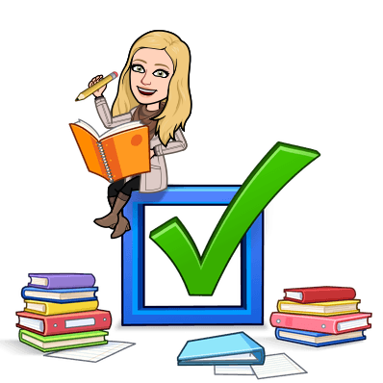
What will we be studying?
Unit 1 – Introduction to Biology & Macromolecules
Unit 2 – Cellular Processes
Unit 3 – Energy
Unit 4 – DNA
Unit 5 – Genetics
Unit 6 – Evolution
Unit 7 – Ecology

Needed for class:
- Miller & Levine Biology Book - A class set will be kept in the room, but you are more than welcome to take a book home for the semester by signing one out (we will rarely be using these).
- You will be given a 3-ring binder for this class with ALL of the material you need for the semester. PLEASE DO NOT LOSE THIS. You will not get another copy. This can be left in the classroom or taken home, up to you
- You need your Chromebook EVERY DAY!! Please don’t forget it! If in ECHS, I will let you know when you MUST bring your Chromebook if you usually bring your laptop.

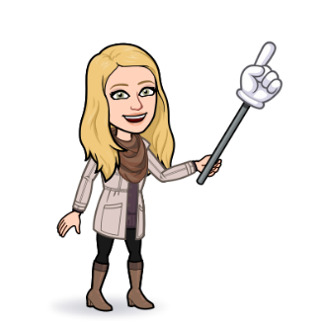
Mrs. LaRosa’s Classroom Rules
Safety always comes first
Come to class
Integrity is important
Embrace your uniqueness
No distractions
Challenge yourself
Engage your mind

Course websites
Google classroom – for all online assignments, warmups, and other items for class
Remind – used for class and individual messaging

How will I be graded?
Grading Policy - Everything that you turn in CAN be graded and recorded. Grades are EARNED, not given, in the following categories:
- Tests, Projects (Major Assessments) – 40%
- Quizzes, Labs (Minor Assessments) – 30%
- Classwork, Homework (Daily Assessments) – 30%
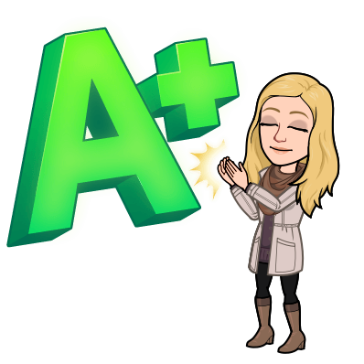
Grading scale
A = 90-100
B = 80-90
C = 70-80
D = 60-70
F = 59 and under

Discussing grades - Speak to me privately before/after class or through email. Use Genesis online to stay current on your grades. If you cannot access genesis, please email Mrs. Greynolds at greynolds@crhsd.org to fix the problem.

Honor Code Violation - Cheating of any kind will result in a zero on any assignment for both parties. Plagiarism is not tolerated! You will receive a 0 for the assignment. DO NOT DO IT!

Late work – I do accept late work (to an extent) with up to a point reduction. I reserve the right to reject any late work based on the circumstances.
Absent work – If you are absent, please check the google classroom STREAM page for the Agenda PPT. If you are absent for a test/quiz, see me as soon as you get back to schedule a time to make it up during SERA. Tests and quizzes will usually be on paper, if not it will be on a locked google form. You have as many days you were absent to make up the work before it is late, then it will be counted as a 0 until it’s made up.
Electronics Policy – No phones during class, no headphones/earbuds during class (unless told to bring/use them). The process will be as followed for not following this rule: warning, phone call/email home, and referral written. Chromebooks are all you will need!
Lav Pass Policy – You have 5 minutes to use the lav and then come back. Any longer is a referral. **School rule, not mine**
During Lab Activities – Show respect towards the classmates you are working with by following directions and paying attention to your work. If you fail to do this, then consequences will follow. Any missed lab that can be made up will be, otherwise you will get an alternative assignment.

STUDENT SIGNATURE DATE

PARENT/GUARDIAN SIGNATURE DATE

